Lesson Exemplar in Integrating Nuclear Science

Detailed Lesson Plan (DLP) in Science Integrating Nuclear Science
school | Caloocan City Science High School | grade level | 10
teacher | Suzzeth U. Dizon | learning area | Biology
teaching dates and time | July 12, 2017 9:20-10:20 AM | quarter | Third

Standards, Topic and References
content standards | The Learners should be able to understand the information stored in DNA as being used to make proteins and how changes in a DNA molecule may cause changes in its product.
performance standards | The learners shall be able to:  1. make a model of DNA showing the interaction of ionizing radiation;  2. make a portfolio about mutation breeding or sterile insect technique being done in the Philippines.
competency | The learners should be able to how protein is made using information from DNA.
competency code | S10LT-IIId-37
topic | Heredity: Inheritance and Variation (DNA Replication)
references | - Crop Improvement Through Mutation Breeding. Quezon City: Philippine Nuclear Research Institute, 2008.  - Science 10 Learner's Module. Department of Education.  - K to 12 Curriculum Guide in Science. Department of Education, August 2016.OpenStax, Concepts of Biology. OpenStax. 25 April 2013. <http://cnx.org/content/col11487/latest/>.  - Cabalfin, Estelita G. . Nuclear Technology Applications in the Philippines. Pdf. Department of Energy, 2009.https://www.doe.gov.ph/sites/default/files/pdf/pep/2009_pep_nuclear_technology_applications_in_the_philippines.pdf  - Philippine Nuclear Research Institute. Improvement of Ornamentals Through Gamma Radiation. Accessed August 4, 2017. http://www.pnri.dost.gov.ph/images/publications/FoodAndAgri/Improvement-of-Ornamentals-Through-Gamma-Irradiation.pdf.  - http://www.frontiersin.org/files/Articles/109688/fmolb-01-00024-r2/image_m/fmolb-01-00024-g001.jpg  - https://www.doe.gov.ph/sites/default/files/pdf/pep/2009_pep_nuclear_technology_applications_in_the_philippines.pdf

Defining Success
Objectives | At the end of the lesson, the student should be able to:  - Describe Chargaff’s rule;  - replicate a given parent strand following the Chargaff’s Rule;  - relate the effects of changes in the DNA sequence to radiation through mutation breeding.
Assessment | - Group Work  - Question and Answer  - Essay  - Four-square analysis
Key Points | - Replication is the making of an exact copy of the DNA molecule. Replication occurs whenever a cell divides. The copy must be 100% accurate (errors = death possibly)  - Chargaff’s Rule, it states that the amount of A is similar to the amount of T, and the amount of G is similar to the amount of C.  - Effect/s of changes in the DNA sequence with the aid of ionizing radiation such as mutation breeding.

Learning Cycle
ELICIT: 3 minutes
ACTIVITY 1
Procedure | Materials and Teacher’s Notes
- Figure 1: Parts of the DNA  1. Identify the specific parts of the DNA.  B  C  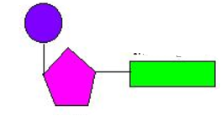  A  - Figure 2: DNA Replication  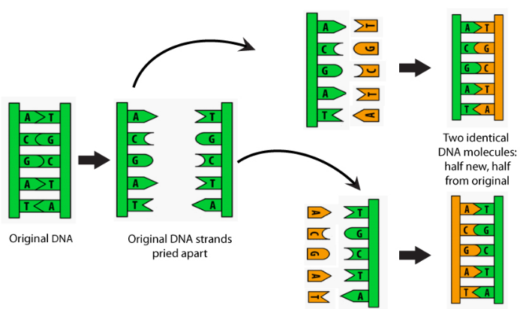  2. Answer the following questions:  a. Describe the biological process involved  Clue: R - - - - - - - --N | - Direction: The following figures will be shown and the learners will answer the questions on each picture. This serves a review of the structure of the DNA.  - Expected Response:  - Parts of the DNA are:  - Phosphate group (PO4)  - Pentose sugar (deoxyribose)  - Nitrogenous base (A,T,G,C)  - Expected Response:  - Replication is the making of the exact copy of the DNA molecule.
ENGAGE: 3 minutes
ACTIVITY 2
pROCEDURE | MATERIALS AND TEACHER’S NOTES
- Trace the process of DNA replication.  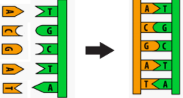  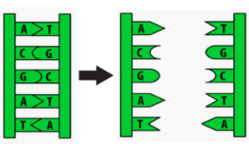  3  1  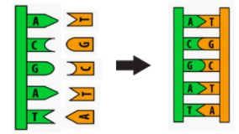  2 | - The teacher shows picture of the DNA replication. Let the learners trace the steps.  - Expected Responses:  - Steps in DNA Replication  - DNA helix unwind and separate.  - Addition of Complimentary nucleotides  - Formation of new DNA strands

EXPLORE: 15 minutes
ACTIVITY 3: Let’s ComPLEMENT
PROCEDURE | MATERIALS AND TEACHER’S NOTES
- Group Activity (See attached Activity Sheet)  - Title: Let’s complEment!  - Pair the DNA strands provided. Do they complement each other?  - Give two significant observations and present it to the class. Answer the guide questions. | - Group the class into four.  - Groups 1 and 2 have pairs of strand that do not complement with each other while Groups 3 and 4 has complementary strands. Each group should have different conditions to observe such as shape, appropriate nitrogenous bases, and base pairings.  - Observations should be posted on the board.

EXPLAIN: 15 minutes
PROCEDURE | MATERIALS AND TEACHER’S NOTES
- From groups 1 and 2 (noncomplementary strands)  - What have you observed from your outputs?  - What are the possible reasons for having such output?  - For group 3 and 4 (complementary strands)  - What have you observed from your outputs?  - What are the possible reasons for having such output?  - Observe the sequences of the DNA. What causes the difference of the two strands? | - Expected Responses:  - Given strands do not complement with each other.  - Noncomplementary:  - the shapes of the represented bases do not fit with the other strand;  - Nitrogenous base pairings are incorrect. Ex: A-G  c. Mix up of nitrogenous bases. Ex: DNA strand has both T and U.  - Expected Responses:  - Given strands complement with each other.  - Complementary:  - the shapes of the represented bases fit with the other strand;  - Nitrogenous base pairings are correct. Ex: A-T and G-C  - Absence of U in the DNA sequence making it possible to have complementary.  - The two strands differ in 2 nitrogenous bases. Changes may be due to exposure to mutagens such as chemicals and radiations.  - Teacher explains:  - The copy must be 100% accurate  (errors = death possibly).  - One strand complements with the other. Following the Chargaff’s Rule, it states that the amount of A is similar to the amount of T, and the amount of G is similar to the amount  of C. (Use the given activity as example to emphasize complementary base pairings.)  - Changes in the DNA sequence may lead to changes in its product. One possible reason is the exposure of the DNA to radiation, to be specific, ionizing radiation.  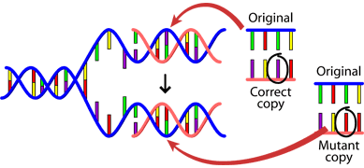  Ionizing radiation  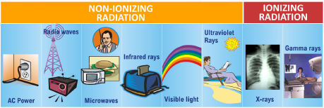  - Show examples of ionizing radiation  - (If time still permits, the teacher may differentiate the direct action and indirect action of ionizing radiation to DNA.)  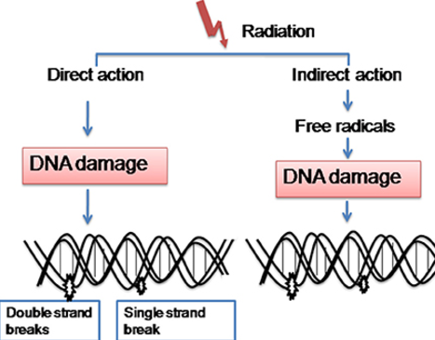

ELABORATE: 10 minutes
PROCEDURE | MATERIALS AND TEACHER’S NOTES
- Call one learner to read the words below:  COMPLEMENT  COMPLIMENT  - What is the difference of the two?  - Replicate the DNA sequence:  - If the first nitrogenous base of the fourth triplet codon of the DNA is replaced by cytosine due to ionizing radiation, how will you describe the outcome?  - Show picture of non-irradiated and irradiated Dracaena sanderiana.  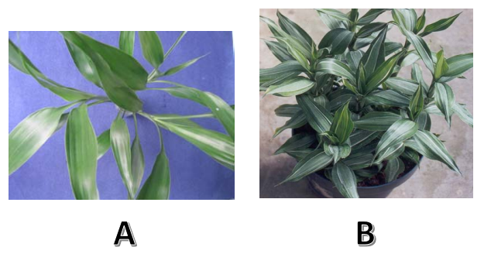  - What is the observable difference of the two plants? | - Teacher integrates the effect of radiation to replicating DNA.  - Expected Responses:  - Spelling is different.  - The meaning of the words are also different. Compliment – polite praise  Complement – addition of something leading to perfection  - Have the same sound  - Teacher explains:  - The analogy here is changing one letter in a word may lead to a new meaning. A change in just one nitrogenous base of the DNA sequence may lead to synthesis of a different product.  - Now let us apply the analogy to real DNA sequences.  - Give one DNA sequence and ask the learners to replicate it.  - Expected Responses:  - GTG CAC TCT TAA GTG GCT CGT AGT ATC ACC TAC TAA TCT TGG  - After exposure to ionizing radiation, the sequence became:  GTG CAC TCT GAA GTG GCT CGT AGT ATC ACC TAC TAA TCT TGG  - Teacher explains:  - Teacher emphasizes that DNA when exposed to ionizing radiation (Gamma rays, x-rays, and electron beams) at controlled amounts will yield benefits to living organisms. One very popular example of this is mutation breeding.  - Teacher Explains:  - Dracaena sanderiana “Marea” is an example of irradiated plant and is a product of mutation breeding (chlorophyll mutant).  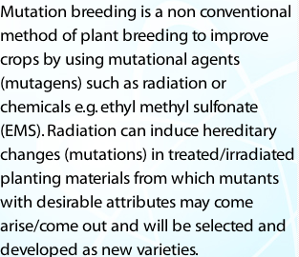  - Mutation breeding as defined by the Philippine Nuclear Research Institute:  - Teacher also elaborates the importance of mutation breeding through this diagram:  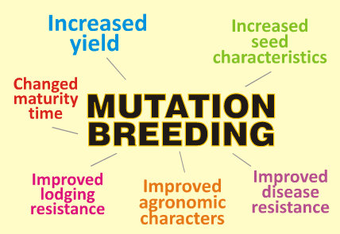  - Other examples of mutation breeding  Beans and Nuts  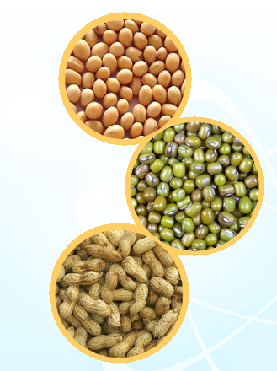  - Please see attached handouts about mutation breeding for more information.

EVALUATE: 6 minutes
PROCEDURE | MATERIALS AND TEACHER’S NOTES
List down 5 key points that you learn from DNA Replication and Mutation Breeding.  Rubrics: | - Expected answers:  - DNA replication is a process of reproducing an exact copy of the strand. The process follows the complementary base pairings and is semiconservative. The process follows the Chargaff’s rule, wherein A pairs with T, and G pairs with C. One of the most common agent of altering DNA sequence is the ionizing radiation. Mutation breeding helps in improving important agricultural products giving a high quality of products from the Philippines. Mutation breeding gives variation on succeeding generations of the mutated plant.  - Call 2-3 learners to give their answers.  - Tell the class to submit their outputs.
   | 3 | 2 | 1
  Concept of DNA Replication | Gave 3 important concepts of DNA replication | Gave 2 important concepts of DNA replication | Gave 1 important concepts of DNA replication
  Mutation Breeding | Gave 3 important concepts of mutation breeding | Gave 2 important concepts of mutation breeding | Gave 1 important concepts of mutation breeding
EXTEND: 5 minutes
PROCEDURE | MATERIALS AND TEACHER’S NOTES
Assignment  Make a four square analysis of a reading entitled:  “Improvement of Ornamentals Through  Gamma Irradiation”  http://www.pnri.dost.gov.ph/images/publications/FoodAndAgri/Improvement-of-Ornamentals-Through-Gamma-Irradiation.pdf | - Expected Output:  - Four Square analysis chart with complete entries.  - Processing of this will be for next meeting  Rubric:
 | 5 | 4 | 3 | 2 | 1
Content and Presentation | Complete, logical outputs on all squares  Diagrams are originally conceptualized | 3 out of 4, logical outputs on all squares  Diagrams are originally conceptualized | 2 out of 4, logical outputs on all squares  Diagrams are adapted from the internet. | Irrelevant entries on the squares including the diagrams. | No output

rEMARKS
rEFLECTIONS
PREPARED BY:
Suzzeth Untalan-Dizon
Caloocan City Science High School
DepEd-Caloocan
09175772778
suzzethdizon@yahoo.com
CHECKED BY:

APPROVED

ATTACHMENTS

Teacher’s Hand out

Sample four-square analysis
8 sentences summary of the article
8 keywords related to the article
Interpretation of the article through drawings
Description of the drawing. Not less than 5 sentences
TITLE of the ARTICLE
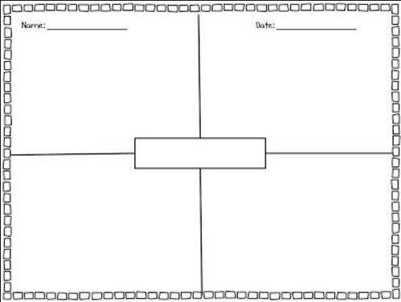

The article for the 4-square analysis can be downloaded at:
http://www.pnri.dost.gov.ph/images/publications/FoodAndAgri/Improvement-of-Ornamentals-Through-Gamma-Irradiation.pdf

Sample DNA strand that could be used during the activity

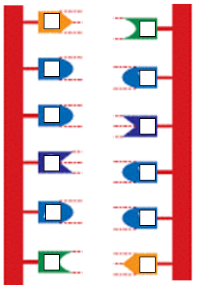
NON COMPLEMENTARY: Please supply the necessary nitrogenous bases as long as they are complements.

COMPLEMENTARY STRANDS: Please supply the necessary complementary nitrogenous bases.
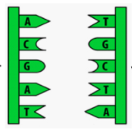

LET’S COMPLeMENT! - ACTIVITY SHEET

I. OBJECTIVE/S:
The learners should be able to:
- Apply the Chargaff’s Rule in replicating DNA strands;
- Determine the possible reasons for having noncomplementary strands;
- Appreciate the effects of ionizing radiation in controlled amounts to living organisms

II. MATERIALS:
DNA strands (cut outs) manila paper
Paste/tape activity sheet
markers
III. PROCEDURES:
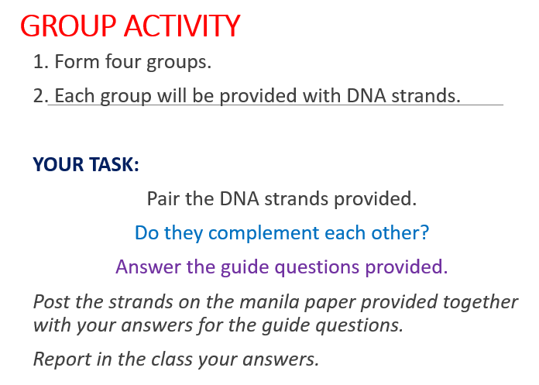

Guide Questions:
- 1. What have you observed from your outputs?
- 2. What are the possible reasons for having such output?
3. Observe the sequences of the DNA. What causes the difference of the two strands?

